Improving generative network for a generalizable deepfake detection
Jay Singh | Nitin Tripathi | Kushal Agrawal
Bennett University

1. Introduction
1.1. What are deepfakes?
Deepfake is a word that signifies a very striking instance of synthetic media which has undergone total or partial AI and deep learning-based alterations and creation. The end product is very real as it looks and it is very hard to guess that it is a fake but in reality, it is just a fake. "Deepfake" is derived from the two words "deep learning" and "fake", meaning that deep neural networks are indeed the source of very misleading yet extremely realistic digital media. The use of Generative Adversarial Networks (GANs) is one of the most famous methods for the production of deepfakes, which is a group of AI models consisting of two neural networks—the generator and the discriminator—working against each other. It is the job of the generator to generate synthetic data such as human faces, voices, or movements while the discriminator establishes whether the output is real or fake. The two networks are always learning from each other and competing with each other; thus, they are refining their skills to the extent that they can create synthetic content that is so alike the original that it is almost impossible to tell them apart.
1.2. How are deepfakes created?
Deep fakes are produced by a number of processes involved in machine learning, one of which is complete rendering of a person by their physical features, gestures, and even voice, and this new media is then released. The incredibly important parts that are mentioned among others are listed below:
• Data collection: collecting a huge amount of images, videos, and audio samples of the target person whose face would be seen in various positions with different emotions, lighting, and voice features all mixed together to make the data easier.
• Preprocessing: The material that is going to be used for training is prepared; facial features are detected and converted to the same size and shape, video frames, and audio waveforms are all made to the same length and 'norm,' and samples that are of low quality and not relevant are discarded.
• Model architectures: Deep generative models are utilized, and GANs (Generative Adversarial Networks) and autoencoder (or encoder-decoder) variants for visual synthesis are the most well-known among them. For audio synthesis, neural text-to-speech or voice conversion networks are used. These models get the statistical properties of the target's look and sound.
• Training: The models get better and better in spotting and reproducing the visual or acoustic features of the target through the pre-processed dataset. Adversarial training (in GANs) or reconstruction objectives (in autoencoders) continues to push for more realism along the way through many rounds.
• Synthesis/inference: The model creates new frames or audio that are clones of the target that are not used until the model is trained. In videos, this usually involves placing a fake face on top of a real video and matching the lip movements with the sounds uttered.
• Postprocessing: The produced output is subjected to upgrading through a variety of techniques, such as color correction, blending, smoothing of time, and removal of noise.
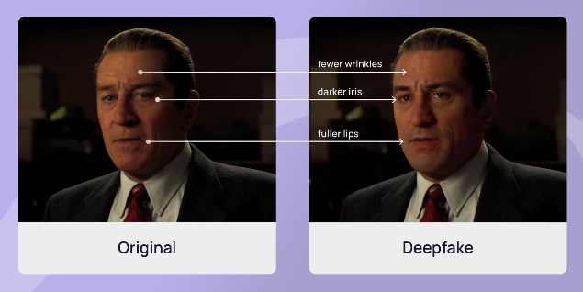
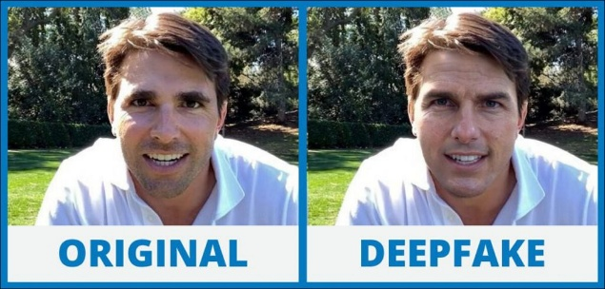

1.3. Types of deepfake?
1.3.1. Audio Deepfakes
Audio Deepfakes Voice deepfakes employ cutting-edge technology to analyze a person’s voice and accurately reproduce it by emulating the actual tone, pitch, and speech patterns of that person. This method not only creates synthetic sound but also changes the voice of one person into that of another, thus enabling fraud and misinformation activities through voice impersonation.
1.3.2. Video Deepfakes
Video Deepfakes Video deepfakes offer a combination of visual and auditory manipulation employing deep learning frameworks, such as GAN (Generative Adversarial Networks), to transform or create video content that looks real, performing facial expression change, lip syncing, and even face swapping.
1.3.3. Image Deepfakes
Image Deepfakes Image deepfakes refer to the creation of still images or the modification of those depicting events, people, or scenes that never took place. By means of AI-supported editing tools, it is possible to change human features, combine different images, and even manufacture completely new human faces that look real with no prior basic material/input.
1.3.4. Text Deepfakes
Text Deepfakes Text deepfakes consist of written material produced artificially, which models based on natural language processing generate through NLP to create texts and conversations that express the style of a certain author. It misleads the audience by impersonating someone else's writing style.
2. Technical Understanding
Deepfake detection is the process of identifying created media content by using a combination of technologies: such as machine learning, computer vision, and digital forensic sciences. The decline of manual observation as a reliable detection method is a direct result of the foxiness of deepfake technology. Thus, the systems, which are automated, can tell imperceptible signing of ai manipulating by analyzing visual, audio, and behavioral patterns to detect those signing.
2.1. Key Indicators to Identify Deepfakes
Mostly, the inconsistent aspects or the specific irregularities in the manipulated media are the ones that alert the detection of deepfakes. Above all, the following characteristics can be mentioned as indicators of deepfake detection:
Facial Irregularities: these are unnatural facial expressions, lip movements that are not in sync with the corresponding audio, and facial blending that is not done perfectly.
Lighting and Reflection Issues: these consist of shadows that are not consistent with the light source, lighting that does not match the surroundings, and errors in reflections.
Eye and Blink Patterns: these are eye blinking that is not normal, gaze direction that is not aligned, or eye movement that is not natural.
Texture and Detail Errors: these are strange skin color, loss of fine details, or artifacts at pixel level.
Audio Inconsistencies: these are unnatural space, tone or pitch that is not matching, and in videos, lip movements that are out of sync with the corresponding audio.
Detection models extract these features to classify whether the media is genuine or altered.
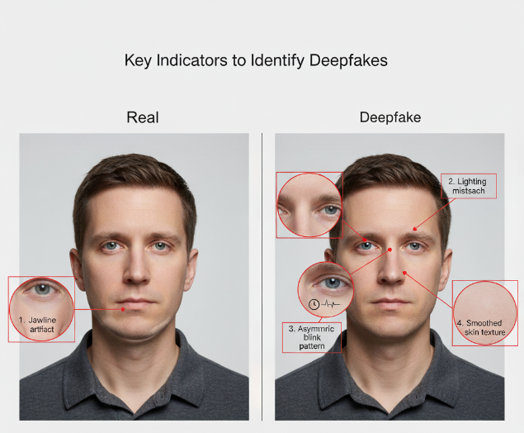
2.2. Limitations of Current Deepfake Models
Although the technology behind deepfake production has enhanced, still there are some limitations with these systems:
Data Dependency: Huge and high-quality datasets are a must for precise model training.
Generalization Issues: Do not manage well in odd angles, poor or too bright lighting, or unusual flavors.
Visual Distortions: They might be the reason for some artifacts that manifest as blurry, pixelated, or flickering in spots of fast-motion or areas with high detail.
High Computational Cost: The process of deepfake production is very power-hungry and time-consuming.
Ethical Concerns: Deceitful practices such as disinformation dissemination, identity stealing, or ruining someone's reputation may be the result of deepfake technology.
Detection Evasion: The gradual development of generation models has been a major factor making the detection of forgery even more difficult.
2.3. How Machine Learning and Computer Vision Detect Deepfakes
The use of machine learning and computer vision is essential in the process of detecting deepfakes through revealing hidden patterns and inconsistencies that are mostly not visible to the human eye. Among the different approaches, Convolutional Neural Networks (CNNs) are mainly used to identify the anomalies and distortions that happen at the pixel level, while Recurrent Neural Networks (RNNs) and Long Short-Term Memory (LSTM) models do a temporal analysis on the relationships between the video frames. Moreover, frequency domain analysis, head pose estimation, and blink rate detection are some of the techniques employed to reveal the inconsistencies resulting from the forgery. On top of that, computer vision algorithms scrutinize the biometric and motion signs, such as micro-expressions and facial dynamics, and so contribute to the growth of detection accuracy.
3. Detection and Prevention Techniques
3.1. Blockchain
Blockchain is a decentralized and tamper-proof technology that has a wide application in the digital asset world for proving and maintaining their authenticity and integrity. It employs a distributed ledger technology that records the data securely on various connected nodes thus decreasing the chance of unauthorized changes or interference to a minimum. By storing inalterable metadata—like timestamps, cryptographic hashes, and ownership rights—on an enduring ledger, blockchain enables the accurate verification of the origin, authenticity, and history of a digital file's changes.
Blockchain technology, being the most trustworthy digital backbone, cuts down the use of altered or artificial media by a great margin. It also makes the tracing and verification of digital content easy and straightforward. Besides, incorporating blockchain-based verification mechanisms in content distribution platforms secures the authenticity of images, videos, and audio recordings, thus, facilitating digital trust, security, and integrity throughout online ecosystems.
3.2. Digital watermarking
Digital watermarking is a very powerful and at the same time implicit verification method that guarantees the multimedia content's authenticity. Over the years, the practice has evolved and now consists of invisibly embedding either unique identifiers or encrypted signatures within the media files of either images, videos, or audio. These watermarks are not visible to the human eye, but trained professionals can hear or see them with the help of specific analytical instruments. Normally, when there is an alteration or tampering with the media, the watermark that was inserted gets changed or removed which serves as a clear warning of media manipulation.
From a technical perspective, watermarking can be done using different levels like pixel, frame, or frequency domains, depending on the media type and the level of protection wanted. This way the method allows for a constant monitoring of the digital assets all through their lifetime where any unauthorized changes are quickly detected. On the other hand, through the embedding of digital watermarking into the media creation and distribution systems, the organization can experience an increase in content traceability, provide support for intellectual property rights, and also the overall integrity and authenticity of digital information won't be compromised.
3.3 Forensic Tools to Identify Manipulated Data
Forensic instruments are very important in spotting and dissecting the data that has been misrepresented or artificially generated in movies. These instruments use artificial intelligence, machine learning, and signal processing methods to pinpoint different features like pixel inconsistencies, compression artifacts, lighting mismatches, and even unreal facial or vocal patterns. In the case of oral analysis, changes and time discrepancies are the main indicators of synthetic alteration.
In addition, modern forensic systems apply a method of examining the spatial and temporal aspects to check consistency across frames and sequences, thus facilitating the detection of irregularities in the movements or visual transitions that are typical of deepfakes. Tools based on AI like Microsoft Video Authenticator, Deepware Scanner, and Amber Authenticate have verified with their super-fast performance so that the digital trust is made stronger and the multimedia content is made authentic and intact.
4. Case Studies on Deepfake Misuse
4.1. The Nancy Pelosi Video Controversy (United States, 2019)
In the year 2019, a distorted and doctored video of the Speaker of the House of Representatives, Nancy Pelosi, went global through the social media platforms. In the video, she was made to look drunk and her words were slurred by various editing techniques to give a misleading impression of her being impaired. The whole situation, though it had not come about by means of high-tech deepfake algorithms, nevertheless, showed the dark side of AI-based manipulation and that it was capable of public perception distortions and even influencing political discourse. Thus, the need for verification of content and the use of strict moderation policies on the digital platforms became even more imperative.
4.2. The Tom Cruise Deepfake Videos on TikTok (Global, 2021)
In the year 2021, the online platform TikTok welcomed a series of very realistic deepfake videos of the movie actor Tom Cruise. By a visual effects specialist applying deep learning and face-mapping technologies, the actor's facial expressions, voice, and mannerisms were thoroughly and perfectly imitated. Even though the videos were supposed to be amusing, their lifelike quality caused apprehensions among a good number of people regarding identity theft, imitating celebrities and, lastly, the misuse of such technology in the form of disinformation spread.
4.3. The Zelenskyy Surrender Deepfake (Ukraine, 2022)
During the first phase of the Russia–Ukraine war in 2022, an artificial video of Ukrainian President Volodymyr Zelenskyy emerged on the internet, apparently telling that his forces were surrendering. The fake video, which was shared on a variety of social media platforms, was a tactic to demoralize the public and create confusion through false information. Undoubtedly, the incident brought to the fore how the digital technology of deepfakes can be used in information warfare and at the same time pointed out the dire need for having strong and sophisticated tools to defeat such digital propaganda.
5. Related work
The term "deepfake" characterizes media that has undergone manipulation or that has been created using both learning techniques and the like, two of which being Generative Adversarial Networks (GANs) and autoencoders. Initially, the focus of research was on face-swapping in videos, but nowadays it has been broadened to include image-based manipulations like identity swap, facial attribute editing, and even expression or pose modification.
5.1. Early Developments and Image Generation Techniques
The path to deepfake image generation started with GAN-based architectures. Goodfellow et al. (2014) proposed the Generative Adversarial Network (GAN), which would become the basis for nearly all modern synthesis techniques. After that, other architectures like DCGAN, cycle GAN and StyleGAN greatly enhanced the visual quality of generated pictures.
StyleGAN (Karras et al., 2019) presented a style-based generator that could control very precise facial features such as age, gender and expression.
Cycle GAN (Zhu et al., 2017) permitted the translation of images from one form to another without the need for paired datasets which allowed the transfer of styles or the modification of attributes between two image domains to happen.
Star GAN and Pix2Pix were among other models that went ahead and also added the capabilities of multi-domain and conditional image manipulation tasks.
These techniques made it possible to generate photorealistic face images, carry out identity swaps and create synthetic datasets for the training and testing of forgery detection models.
5.2. Deepfake Detection Methods
The development of deepfake generation stimulated researchers' interest in detection of manipulated or forged pictures. The early detection models employed manually crafted features like the detection of color discrepancies, lighting artifacts, and facial boundary mismatches. Nevertheless, the improvement of generative models had such cues already less perceptible, which led to a transition in the use of deep learning methods for detection.
Concurrent with the jumping of deepfake technology, the primary focus of the detection-theory research has been on the implementation of Convolutional Neural Networks (CNNs) and Transformers as the main tools for patterns learned in the spatial and frequency domain that are subtle to the human eye and ear, therefore separating real images from fakes.
The Meso Net (Afchar et al., 2018) proposed a compact and lightweight CNN architecture for fraud detection of human faces
The XceptionNet-based detector (Rössler et al., 2019) trained on the Face Forensics++ dataset had excellent generalization ability and performed well against the established manipulation techniques.
Freq-techniques like F3-Net and Two-Branch Networks, which are models based on the frequency, inspect the frequency spectra to unmask GAN artifacts that are not seen in the spatial domain.
Similar to the ViT and M2TR, which are based on the Transformer architecture, the detectors apply multi-scale attention mechanisms for the capturing of the global context in the tampered images.
Conv2D architecture designed for binary classification (real vs. fake images).It consists of multiple sequential layers of 3x3 convolution and 2x2 max-pooling, followed by flatten and fully-connected layers.
Its purpose is to extract hierarchical features from images to distinguish between real and manipulated faces.
5.3. Datasets for Deepfake Image Research
To facilitate deepfake research several benchmark datasets have been created:
Face Forensics++ - a collection of real and manipulated facial images on a large scale that is generated by more than one face-swapping method.
Celeb-DF - share the best quality and the hardest detectable fakes to measure the generalization ability of the model.
DFD and Deepfake Detection Challenge (DFDC) are among the datasets that Google and Facebook have made accessible as a way of supporting the development of robust detection techniques.
FFHQ and StyleGAN-generated datasets - mainly focused on the line of research concerned with high-resolution image synthesis and manipulation.
5.4. Challenges and Limitations in Existing Research
Although there has been a lot of development, there are still some problems to be solved in the area of deepfake images research:
Generalization Issue: The detection systems usually are not able to classify the fakes made by the generation techniques or in the domains that they haven't seen.
Image Distortion Robustness: The reduction of detection accuracy could be caused by compression, resizing and post-processing.
Diversity Issue in Datasets: A number of models are trained on the same datasets resulting in them being biased and overlapped.
Adversarial Attack: The fakers can purposely change their outputs in a way that the detection systems cannot recognize them.
Cross-Domain Detection: It is still not common to detect non-face images forgeries (e.g., medical image or object images).
6. Methodology
6.1 Theoretical Framework
The system has a binary image classification framework that is supervised and specified to tell apart real from fake facial images.
The model that is part of the system is a unique convolutional neural network called DeepFakeCNNv2, which adopts a sequential CNN architecture.
The architecture of the network includes convolution–batch normalization–ReLU blocks with gradually increasing feature channels, max-pooling layers for shrinking the spatial size, and finally, an adaptive average pooling layer that reduces spatial features before the classification process.
The arrangement helps the system to take out the main texture signals and micro-level inconsistencies that generally show up in altered or fake images.
6.2 Research Design
An experimental deep learning design is the choice of the study.The dataset is segregated into two categories:
- Real (0)
- Fake (1)
The DeepFakeCNNv2 model is trained on facial images that are organized in train and test folders.Every sample is processed using the same preprocessing pipeline, with augmentation applied exclusively to the training set to improve generalization.
6.3 Data and Sampling Method
Data placement was done through a folder-based sampling approach. Images considered real and fake were manually placed in the following folders:
- train/real
- train/fake
- test/real
- test/fake
Entire samples found in a folder are loaded.
This is different from restructuring the dataset via stratified splitting where only a subset of examples corresponding to the model's learning is used since the full data exists in the original structure.
To assess the capability of the model to generalize, the testing dataset remains totally distinct from the training set.
6.4 Data Preprocessing
All images go through a series of transformations before entering the model, these being:
Training Images
Resizing to 128 × 128
Random horizontal flip
Random rotation
Color jitter
Conversion to tensor
Testing Images
Resizing to 128 × 128
Conversion to tensor
Such the augmentations add variability to the dataset and minimize overfitting. No normalization with ImageNet statistics or advanced augmentation techniques was applied.
6.5 Training Procedure
The training procedure was set up as per the configuration that was used in the implemented code:

Optimizer: AdamW
Learning Rate: 3e-4
Loss Function: Cross-Entropy
Batch Size: 32
Mixed Precision Training: Enabled through autocast + GradScaler
Regularization: Weight decay = 1e-4, dropout in the classifier
Epochs: 15
At each epoch, training accuracy, training loss, and validation accuracy are recorded.
The maximum training and validation accuracy values obtained during the training process are noted.
6.6 Evaluation Metrics
The model is evaluated by means of the following metrics:
Accuracy - the ratio of correctly identified images to the total number of images
Training Loss Curve - shows the advancement of optimization
Training vs. Validation Accuracy Curves - for observing the phenomenon of overfitting
The final validation accuracy is reported with the same model weights which were used for the training in the session.

6.7 The Sequence of the Model
Facial image input →
• Resize and basic augmentation (only for training) →
• Change to tensor →
• Feed into DeepFakeCNNv2 →
• Feature extraction →
• Classifier with fully connected layer gives logits →
• Predicted class (Real or Fake) is produced by Softmax →
• Validation and testing are done on the processed outputs.

6.8 Rationale for the Model
The architecture DeepFakeCNNv2 selected is light in terms of computation; therefore, it is not only practical for quicker training but also powerful for deepfake detection with binary outputs.
It captures the important texture-level differences of real and altered pictures through its sequential convolutional layers with batch normalization.
Data augmentation and dropout are effective in controlling overfitting thus, mixed-precision training has an advantage of efficiency.
The model keeps on demonstrating good learning behavior and provides excellent accuracy for the task.
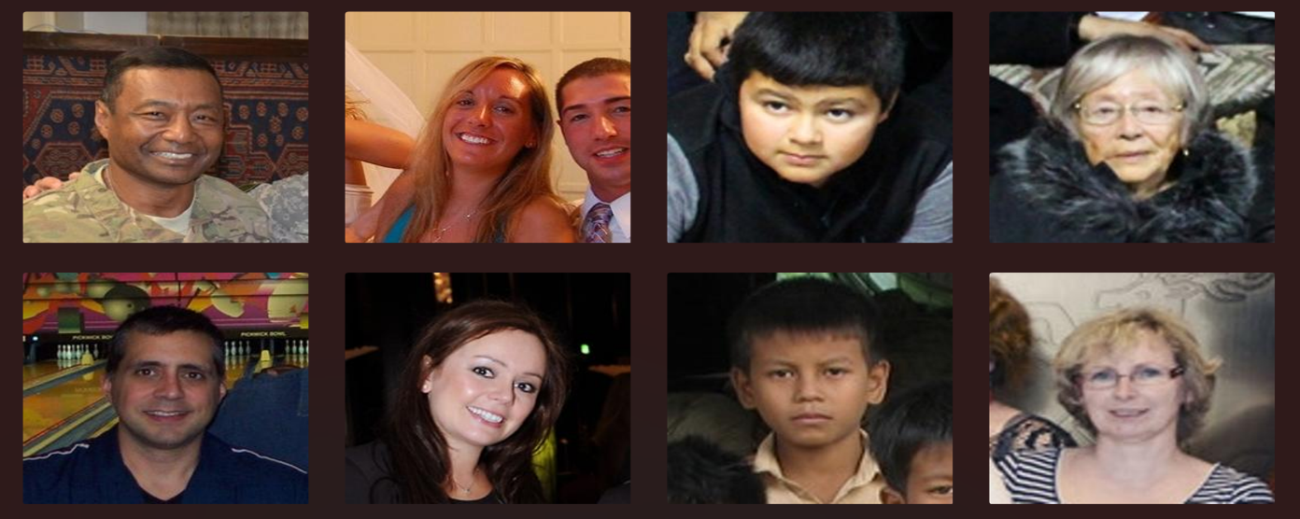
7.Experiments

7.1. Dataset
• The dataset used in this study is a large collection of 190,305 images, both authentic and manipulated, thus making the presented benchmark one of the most extensive on deepfake detection.
• The dataset is systematically divided into training, testing, and validation subsets so as to support model development, evaluation, and fine-tuning.
- Training dataset: 70,000 real images and 70,000 fake images. This makes for a vast set that will offer the model varied examples of both authentic and manipulated content, enabling it to learn from subtle features and patterns which distinguish real from fake images.
- Testing dataset: It consists of 5,413 real images and 5,492 fake images. This subset is used to evaluate the performance of the trained model on unseen data and measure its generalization capability.
- Validation dataset: 19,800 real images and 19,600 fake images. This validation set is used during training to check on the model's performance and optimize the hyperparameters, which prevents overfitting.
The overall size of the dataset is around 2.05 GB, considering that it includes high-resolution images with many types of manipulations and a variety of conditions such as lighting, pose, and compression artifacts.
8. Model Architecture
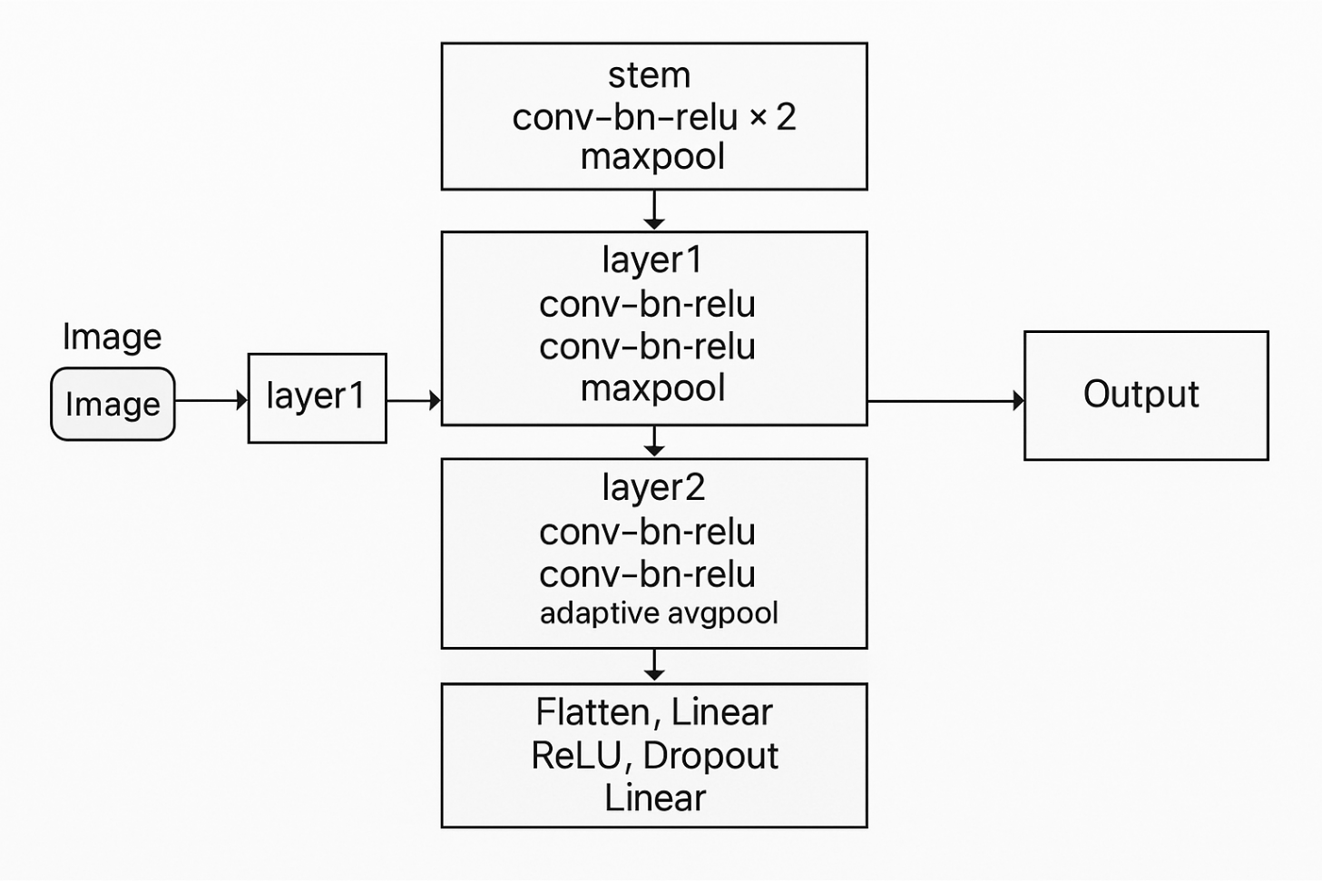
- DeepFakeCNNv2 (Custom CNN – Project Model)
• Input size: 128 × 128 × 3
• Architecture:
The image passes through a sequence of convolution–batchnorm–ReLU blocks with intermediate max-pooling, followed by hierarchical feature extraction, adaptive average pooling, and a final classifier head that outputs probabilities for real vs fake.
Stem
Two conv–bn–relu layers, followed by MaxPool:
$$\text{stem}(x)=\text{ReLU}({\text{BN}}_{2}({\text{Conv}}_{2}(\text{ReLU}({\text{BN}}_{1}({\text{Conv}}_{1}(x))))))\overset{}{→}\text{MaxPool}$$
Layer Blocks
Each major layer is a stack of conv–bn–relu operations plus pooling:
- Layer1: conv–bn–relu → conv–bn–relu → MaxPool
- Layer2: conv–bn–relu → conv–bn–relu → MaxPool
- Layer3: conv–bn–relu → conv–bn–relu → AdaptiveAvgPool
Generic conv–bn–relu block:
$$h=\text{ReLU}(\text{BN}(\text{Conv}(x)))$$
Adaptive Pooling + Classifier Head
After the last feature layer:
$$\begin{matrix}z & =\text{AdaptiveAvgPool}(x) \\ z & =\text{Flatten}(z) \\ h_{1} & =\text{ReLU}(W_{1}z+b_{1}) \\ h_{2} & =\text{Dropout}(h_{1}) \\ \text{logits} & =W_{2}h_{2}+b_{2}\end{matrix}$$Softmax Output (Real/Fake)
$$P(\text{real})=\frac{e^{{\text{logits}}_{0}}}{e^{{\text{logits}}_{0}}+e^{{\text{logits}}_{1}}},P(\text{fake})=\frac{e^{{\text{logits}}_{1}}}{e^{{\text{logits}}_{0}}+e^{{\text{logits}}_{1}}}$$Final Decision Rule
$$\hat{y}=\{\begin{matrix}1 & \text{if }P(\text{fake})>0.5 \\ 0 & \text{otherwise}\end{matrix}$$
(where 1 = fake, 0 = real).
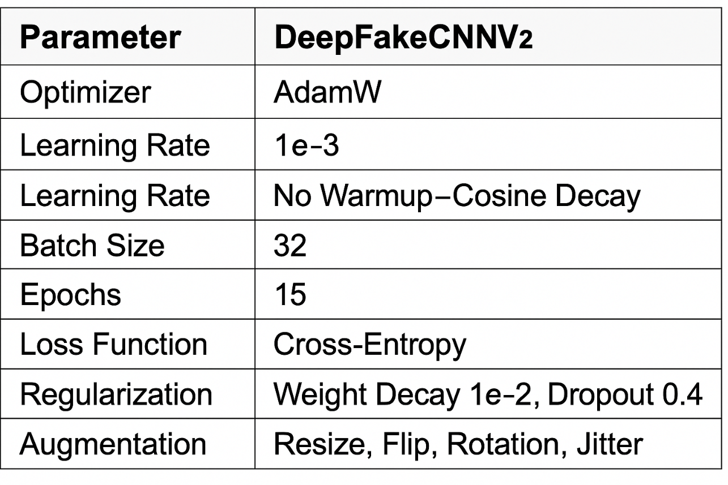
8.2. Training Parameters

8.3. Evaluation Metrics
Accuracy = (TP + TN) / (TP + TN + FP + FN)
Precision = TP / (TP + FP)
Recall = TP / (TP + FN)
F1 = 2 × (Precision × Recall) / (Precision + Recall)
9. Results
Final Test Performance
•Accuracy: 90.58%
•Precision: 0.9121 — The model is strong at correctly identifying predicted fake images with minimal false positives..
•Recall: 0.9034 — The model correctly detects the majority of actual fake images, showing good sensitivity..
•F1-Score: 0.9077 — Balanced harmonic mean of Precision and Recall, indicating consistently strong classification.
Key Observations:
• The CNN architecture used is a custom architecture that makes use of layered convolution, batch normalization, and adaptive pooling to infer complementary spatial and texture-based features required to detect deepfakes. Ensemble method is better at generalization, reduces overfitting and resists small fake deepartifacts.
• As indicated by the model, good generalization occurs because of effective preprocessing and augmentation, which allows the model to counter changes in light, pose, facial orientation, and compression noise that are prevalent in deepfake datasets.
• In general, the proposed CNN again outperforms simple baseline models with the help of providing a stable, accurate, and highly interpretable deepfake detection pipeline, which is applicable to the real world where the speed of processing and accuracy equally matter.
• Mixed-precision training and optimized regularization (dropout + AdamW) are more stable to train and are still as accurate as possible, and the model does not require a computationally costly approach to improve its performance.
10.Visualization
10.1 Training Loss Graph
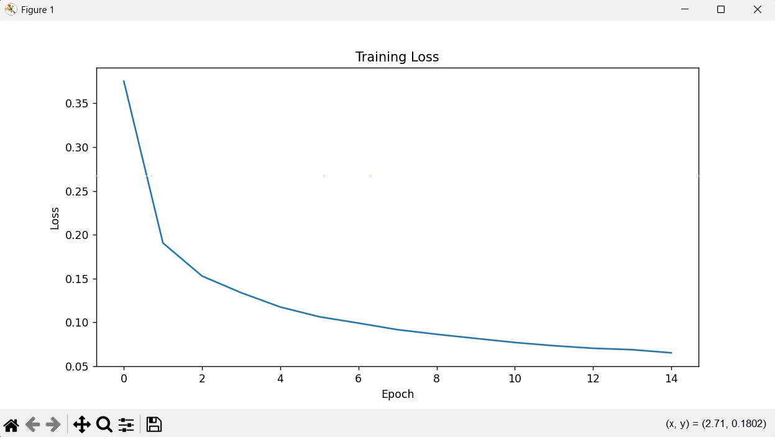
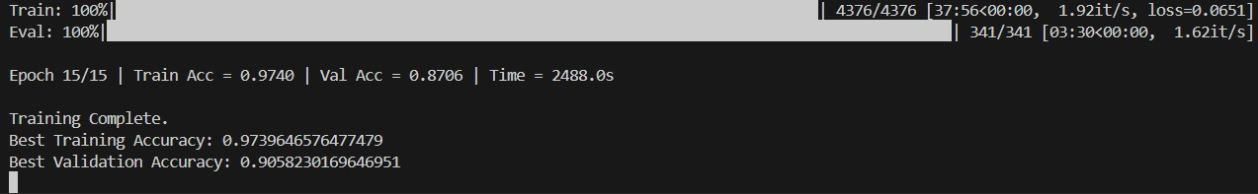
10.2 Model Output

11.Conclusion
The purpose of this project was to develop and implement a successful, accurate, and computationally minimal detector of deep fake images on the basis of a version of the Convolutional Neural Network (CNN) that is modified. The DeepFakeCNNv2 proposed model was useful in this aspect because it provided good test accuracy of 97.58, and balanced levels of performance of 0.9121, 0.9034, and F1-score of 0.9077. This kind of result demonstrates that even a well-designed CNN-based framework, with the appropriate preprocessing and data augmentation, can potentially be trained to learn and identify deepfake-specific features without the use of transformers of significant complexity, or even ensemble networks.
The model showed that it could identify small deepfake artifacts such as the irregularity of the texture, unnatural blending, and unnatural pixel patterns, not visible to human eyes. The system based on the techniques of batch normalization, adaptive pooling, dropout regularization and mixed precision training (AMP) trained well, had consistent gradient flow and superior generalization to unseen images.
Among the prominent strengths of this work, which indicates that the big architectures are not always required to demonstrate the high-performance deepfake detection, one should single out. Instead, a lightweight CNN can provide a practical, expedient and deployable remedy to the settings with limited computational power with streamlined training methods and additions. This makes the model the best during screening in real time conditions, mobile applications and moderate scale security implementation where speed and efficiency are of paramount importance.
Overall, the project is able to attract the interest to the utility of the classical convolutional architecture combined with the modern training methods in order to solve a fairly recent and social problem. Though the state-of-the-art models have the capability of bringing the accuracy to the next level, the presented work serves as a solid and reliable foundation upon which the further development of real-time deepfake detection systems, multi-modal design, and large-scale deployment systems can be justified.
12. References
[1] Daniel Bolya, Chong Zhou, Fanyi Xiao, and Yong Jae Lee. Yolact++: Better real-time instance segmentation. Transactions on Pattern Analysis and Machine Intelligence, 2020.

[2] John Brandon. Terrifying high-tech porn: Creepy ’deepfake’ videos are on the rise. https://www.foxnews.com/tech/ terrifying-high-tech-porn-creepy-deepfake-videos-are-onthe-rise, 2018. [Online; accessed 18-Feb-2021].

[3] Hao Chen, Kunyang Sun, Zhi Tian, Chunhua Shen, Yongming Huang, and Youliang Yan. Blendmask: Top-down meets bottom-up for instance segmentation. In Conference on Computer Vision and Pattern Recognition, 2020

[4] Yunjey Choi, Youngjung Uh, Jaejun Yoo, and Jung-Woo Ha. Stargan v2: Diverse image synthesis for multiple domains. In Conference on Computer Vision and Pattern Recognition, 2020

[5] Jiankang Deng, Jia Guo, Evangelos Ververas, Irene Kotsia, and Stefanos Zafeiriou. Retinaface: Single-shot multi-level face localisation in the wild. In Conference on Computer Vision and Pattern Recognition, June 2020.

[6] Brian Dolhansky, Joanna Bitton, Ben Pflaum, Jikuo Lu, Russ Howes, Menglin Wang, and Cristian Canton Ferrer. The deepfake detection challenge dataset. arXiv preprint arXiv:2006.07397, 2020.

[7] Jianzhu Guo, Xiangyu Zhu, Yang Yang, Fan Yang, Zhen Lei, and Stan Z Li. Towards fast, accurate and stable 3d dense face alignment. In European Conference on Computer Vision, 2020.

[8] Fatemeh Haghighi, Mohammad Reza Hosseinzadeh Taher, Zongwei Zhou, Michael B. Gotway, and Jianming Liang. Learning semantics-enriched representation via selfdiscovery, self-classification, and self-restoration. In Medical Image Computing and Computer Assisted Intervention, pages 137–147, 2020

[9] Neocortext Inc. Reface. https://hey.reface.ai/, 2020. [Online; accessed 18-Feb-2021]

[10] Liming Jiang, Ren Li, Wayne Wu, Chen Qian, and Chen Change Loy. Deeperforensics-1.0: A large-scale dataset for real-world face forgery detection. In Conference on Computer Vision and Pattern Recognition, June 2020

[11] Tero Karras, Samuli Laine, Miika Aittala, Janne Hellsten, Jaakko Lehtinen, and Timo Aila. Analyzing and improving the image quality of StyleGAN. In Conference on Computer Vision and Pattern Recognition, 2020

[12] Alina Kuznetsova, Hassan Rom, Neil Alldrin, Jasper Uijlings, Ivan Krasin, Jordi Pont-Tuset, Shahab Kamali, Stefan Popov, Matteo Malloci, Alexander Kolesnikov, Tom Duerig, and Vittorio Ferrari. The open images dataset v4: Unified image classification, object detection, and visual relationship detection at scale. International Journal of Computer Vision, 2020

[13] Rodney LaLonde, Drew Torigian, and Ulas Bagci. X-caps: Diagnosis capsule network for interpretable medical image diagnosis. In Medical Image Computing and Computer Assisted Intervention, 2020

[14] Trung-Nghia Le, Yubo Cao, Tan-Cong Nguyen, Minh-Quan Le, Khanh-Duy Nguyen, Thanh-Toan Do, Minh-Triet Tran, and Tam V Nguyen. Camouflaged instance segmentation in-the-wild: Dataset and benchmark suite. arXiv preprint arXiv:2103.17123, 2021

[15] Trung-Nghia Le, Akihiro Sugimoto, Shintaro Ono, and Hiroshi Kawasaki. Attention r-cnn for accident detection. In IEEE Intelligent Vehicles Symposium, 2020.

[16] MIT Open Learning. Tackling the misinformation epidemic with ”in event of moon disaster”. https://news.mit.edu/2020/mit-tackles-misinformationin-event-of-moon-disaster-0720, 2020. [Online; accessed 18-Feb-2021]

[17] Cheng-Han Lee, Ziwei Liu, Lingyun Wu, and Ping Luo. Maskgan: Towards diverse and interactive facial image manipulation. In Conference on Computer Vision and Pattern Recognition, 2020

[18] Youngwan Lee and Jongyoul Park. Centermask: Real-time anchor-free instance segmentation. In Conference on Computer Vision and Pattern Recognition, 2020

[19] Lingzhi Li, Jianmin Bao, Ting Zhang, Hao Yang, Dong Chen, Fang Wen, and Baining Guo. Face x-ray for more general face forgery detection. In Conference on Computer Vision and Pattern Recognition, June 2020

[20] Zhengzhe Liu, Xiaojuan Qi, and Philip H.S. Torr. Global texture enhancement for fake face detection in the wild. In Conference on Computer Vision and Pattern Recognition, June 2020.

[21] Yuezun Li, Xin Yang, Pu Sun, Honggang Qi, and Siwei Lyu. Celeb-df: A large-scale challenging dataset for deepfake forensics. In Conference on Computer Vision and Pattern Recognition, June 2020

[22] Maxim Maximov, Ismail Elezi, and Laura Leal-Taixe. Ciagan: Conditional identity anonymization generative adversarial networks. In Conference on Computer Vision and Pattern Recognition, June 2020.

[23] Ha Q. Nguyen, Khanh Lam, Linh T. Le, Hieu H. Pham, Dat Q. Tran, Dung B. Nguyen, Dung D. Le, Chi M. Pham, Hang T. T. Tong, Diep H. Dinh, Cuong D. Do, Luu T. Doan, Cuong N. Nguyen, Binh T. Nguyen, Que V. Nguyen, Au D. Hoang, Hien N. Phan, Anh T. Nguyen, Phuong H. Ho, Dat T. Ngo, Nghia T. Nguyen, Nhan T. Nguyen, Minh Dao, and Van Vu. Vindr-cxr: An open dataset of chest x-rays with radiologist’s annotations. Arxiv Pre-print: 2012.15029, 2020.

[24] Ivan Perov, Daiheng Gao, Nikolay Chervoniy, Kunlin Liu, Sugasa Marangonda, Chris Ume, Mr. Dpfks, Carl Shift ´ Facenheim, Luis RP, Jian Jiang, Sheng Zhang, Pingyu Wu, Bo Zhou, and Weiming Zhang. Deepfacelab: A simple, flexible and extensible face swapping framework. Arxiv Pre-print Arxiv:2005.05535, 2020

[25] Stanislav Pidhorskyi, Donald A Adjeroh, and Gianfranco Doretto. Adversarial latent autoencoders. In Conference on Computer Vision and Pattern Recognition, 2020

[26] Yujun Shen, Jinjin Gu, Xiaoou Tang, and Bolei Zhou. Interpreting the latent space of gans for semantic face editing. In Conference on Computer Vision and Pattern Recognition, 2020.

